**GEOG920: Quantitative Methods in Quaternary Paleoclimatology**

Assignment 1- Neotoma

**II. Search for Data**

1**. Find a Site**

a. The Lat/Lon of Devils lake is: Longitude= -89.73205, Latitude= 43. 4178. The Site ID: 666.

2. **Find a Taxon**

a**. Find all the sites with at least 20% Picea (spruce) pollen, between 21,000 and 18,000 years ago:**

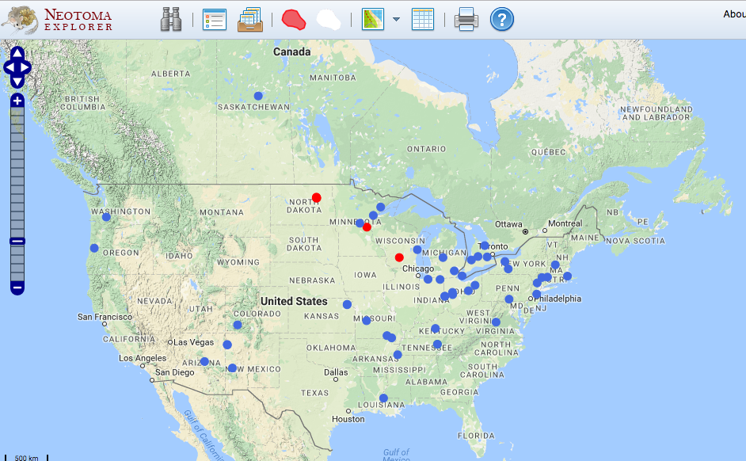

b. Louisiana is the state that has the southernmost location of Picea in this search.

3. **Find all sites produced by a researcher**

a. **Find all sites produced by Lou Maher:**

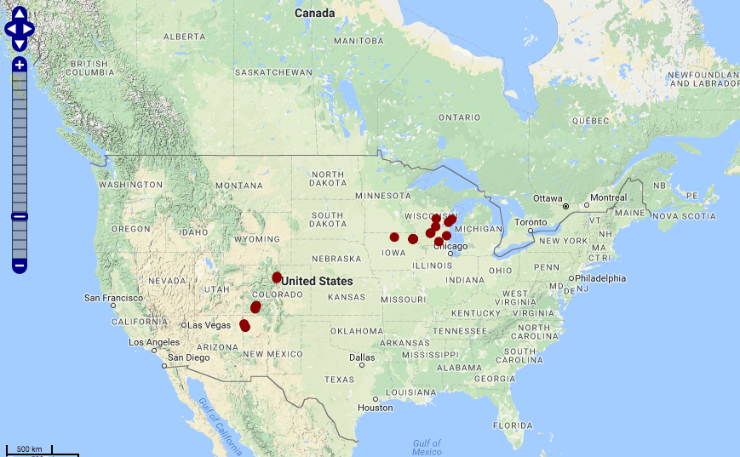

b. Wisconsin, Iowa, Colorado, Arizona

4. **Find all fossil pollen records in North America**

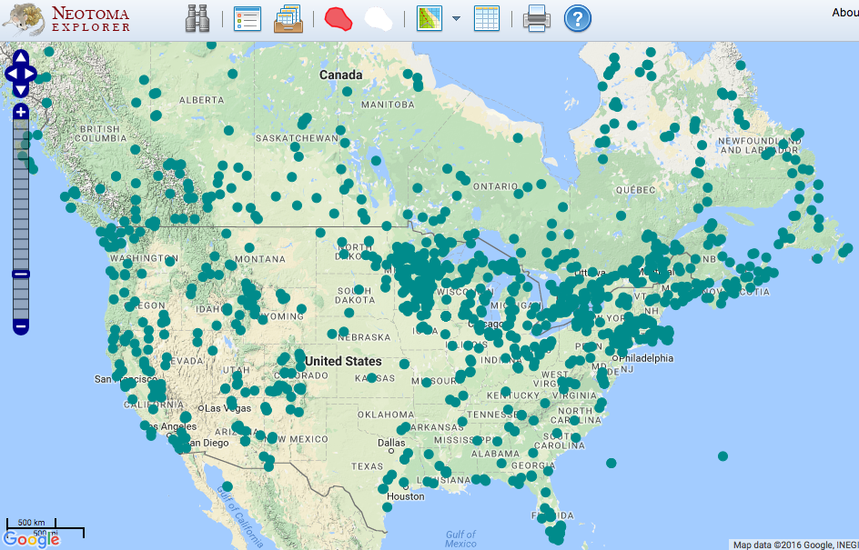 a.

c. **Two years and $30,000 per a single fossil pollen record, therefore, how many person-years and dollars did it take to produce these fossil pollen records?**: There are 2,665 records, therefore it took about $79,950,000 and 5,330 yeas to collect this data!

d. **There is a very dense network of fossil pollen sites in an arc stretching from Minnesota to Nova Scotia. Why might there be such a dense network in this region?**

The reason we see a dense network of fossil pollen sites in this area is because of the presence of several lakes which were formed when the ice sheet was retreating.

5. **Show/Hide Search Reslts**

6. **Multi-Taxon Search**

a. **Find all sites with at least 20% Picea pollen between 15,000 and 12,000 years ago:**

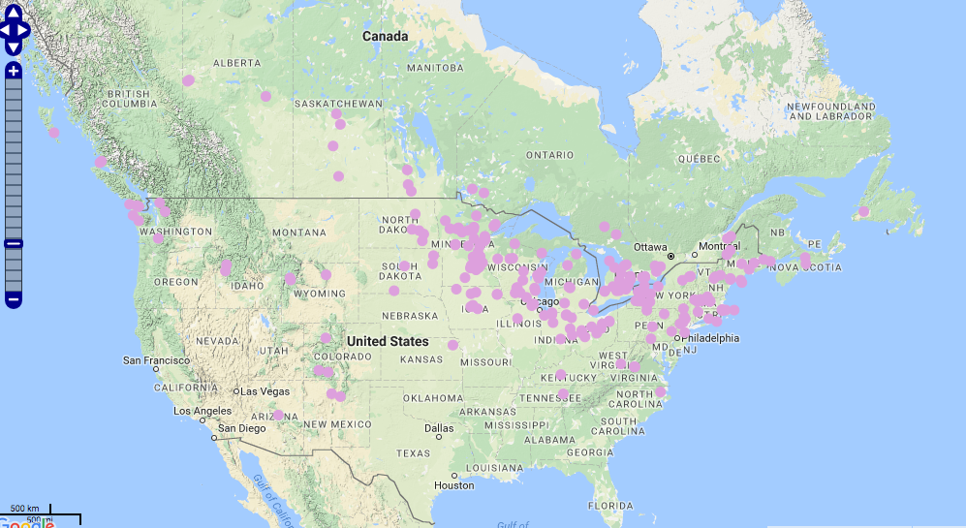

b. **Find all sites with Mummut (mastodon) between 15,000 and 12,000 years ago:**

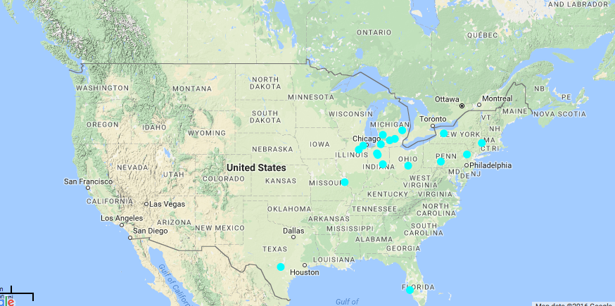

**c. Does mastodon tend to live in places with spruce, or without spruce? Suggest two hypotheses that might explain the observed association**

The mastodon tends to live in places with spruce. One hypothesis to explain this association could be that the mastodon consumed spruce for its diet. Another reason this could be is because to live, they seek similar environments (cold).

7. **Multi-Time Search**

a. Hide previous searches

b. F**ind all sites with at least 20% Picea pollen between 21,000 and 18,000 years ago**: (47 sites)

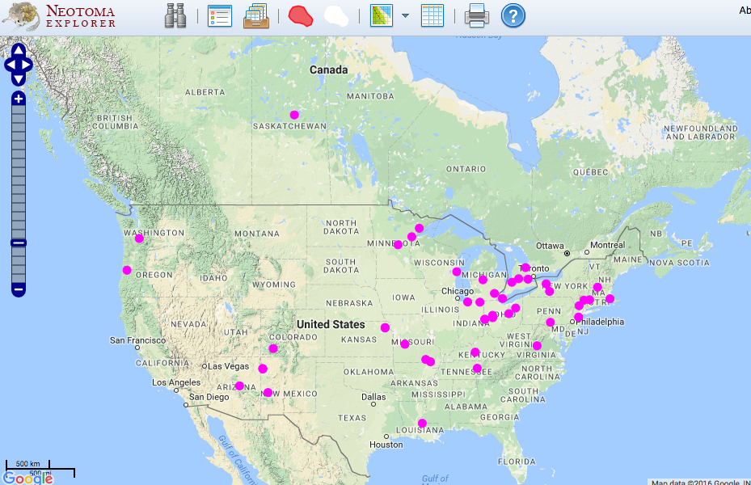

c. **Find all sites with at least 20% Picea pollen between 15,000 and 12,000 years ago:** (242 sites)

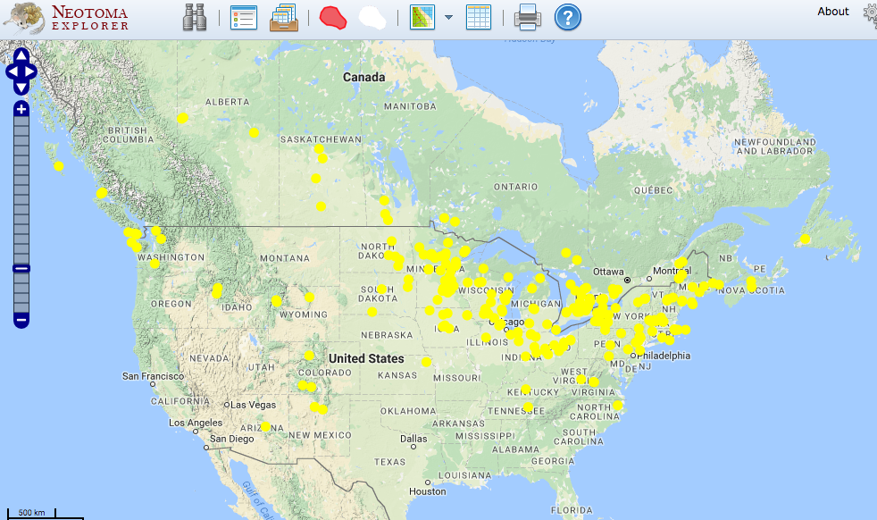

d. **Find all sites with at least 20% Picea pollen between 10,000 and 7,000 years ago:** (151 sites)

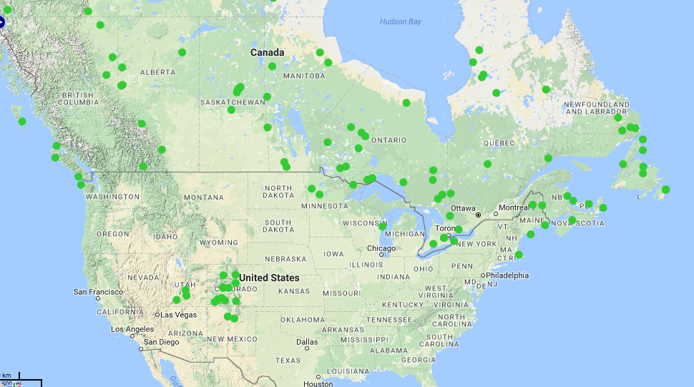

e. **Find all sites with at least 20% Picea pollen between 5,000 and 1,000 years ago:** (215 sites)

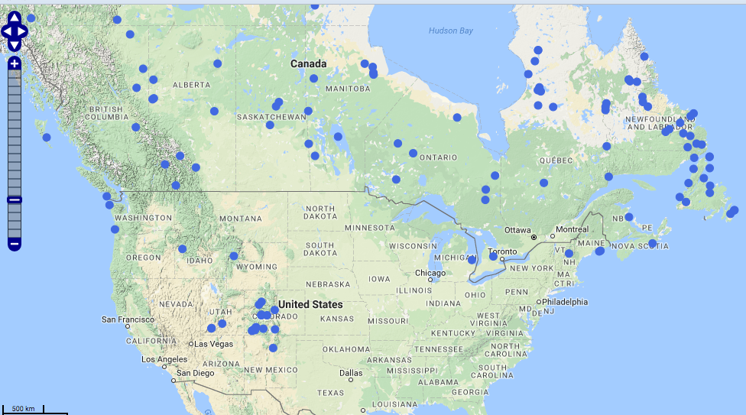

**f. Describe the history of Picea distributions in eastern North America over the last 21,000 yeas (i.e. ignore the Rockies and points west). What environmental changes be causing this shift in Picea distributions? Given these trees are sessile (immobile) organisms, what processes might allow the observed range shifts?**

From 21,000 to 18,000 years ago, most of the Picea distribution was concentrated in the upper Midwest near Michigan/Ohio, with about 47 sites. Then, during 15,000 to 12,000 years ago, most of the pollen was concentrated thickly more up north near the Midwest/Canada border. There were 242 sites then, much more than before. Then from 10,000 to 7.000 years ago, the number of sites were still high (151) even though it decreased, yet they migrated up north more in Canada. Then from 5,000 to 1,000 years ago, most of the sites were all in Canada and still up North (abundance at about 215 sites). Therefore, from this data, we can see how the pollen sites migrated north from 15,000 years to present. Therefore, we can observe how the pollen reacted in relation to Earth’s current warming. As the climate warms, they migrate north to seek colder climates to adapt to the changing environment.

**III. View Data**

a. Go find Devils Lake again.

b. Diagram:

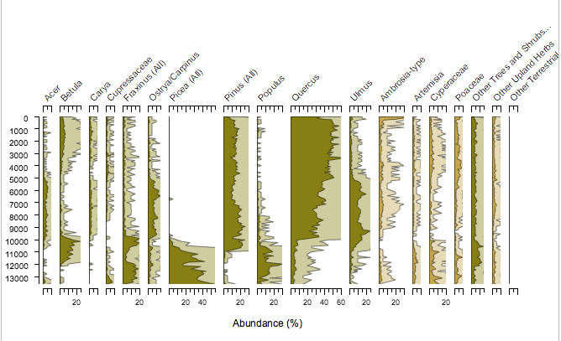

ci. **What was the most abundant plant taxon at Devils Lake during the end of the Pleistocene (prior to 11,000 years):** Picea (Spruce)

cii. **What has been the most abundant taxon during the Holocene (from 11,000 years ago to present):** Quercus (oak)

d. **Using the information in the Chronology tab, how many age controls are stored for Devil’s Lake? How many of these are radiocarbon dates?:** 11 C-14 dates, 3 basal dates. Therefore, 11/14 of these dates are radiocarbon.

**e. What publications are listed for Devil’s Lake?** Maher, L.J. Jr. (1982). “The palynology of Devils Lake, Sauk County, Wisconsin,” Quaternary History of the Driftles.

**4. Download Data**

5. **What are the two most abundant taxa at Depth=1cm?** The most abundant is Quercus (Oak) at 275 and Ambrosia-type (Ragweed) at 230.

**5. Explore on Your Own**

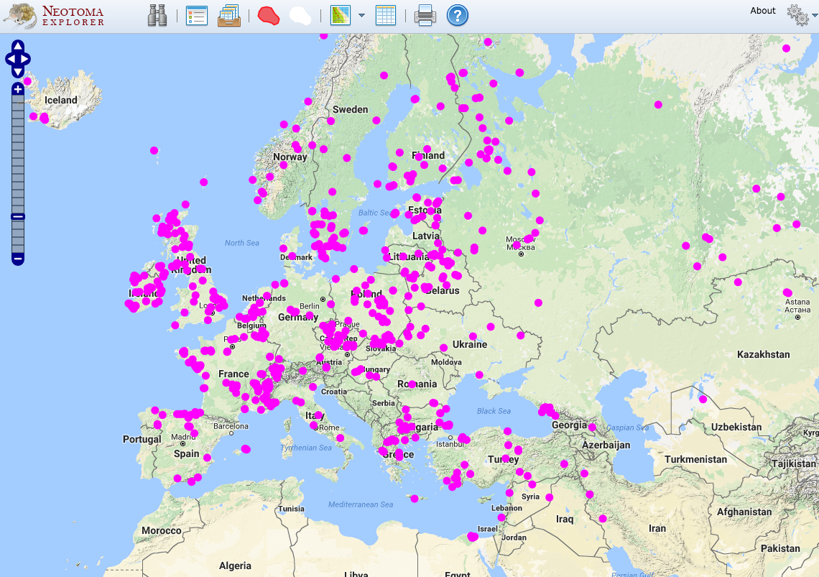I first was just curious and wanted to see how many pollen records there were in Europe compared to North America.When I did a basic search of pollen records in Europe, I found that Europe has 658 sites with pollen records (as compared to the 2,665 in mid-upper North America).

From this pollen data, I went ahead and did a similar routine as what was done in the previous North America section and saw how the abundance of Picea (Spruce) changed over time. To do this, I tested to see where Picea pollen was present at the same time steps as before (with >0% abundance). To do this, I used the advance search setting, used dataset type as pollen, space setting as “search by extent” (current map extent) while zoomed in on only Europe, and searched for Picea taxon throughout the different time steps.

From 21,000 years ago to 18,000 years ago, there were only six sites recorded. From 18,000-15,000 there were 14 sites recorded. From 15,000-12,000 yeas there were 60 sites recorded. From 12,000-9,000 there were 109 sites recorded. From 9,000-6,000 there were 128 sites recorded. From 6,000-3,000 years there were 145 sites recorded. From 3,000-present there were 158 sites recorded. Figures (Progressing from 21,000 years ago – present with each figure representing a three-year-span):

